Tursynbay Mansur CS - 2428
Remote Code Execution
Remote Code Execution (RCE) is a critical security vulnerability that allows an attacker to execute arbitrary code or commands on a target system or server remotely. This type of vulnerability typically arises when a software application or service fails to properly validate or sanitize user input, allowing attackers to inject and execute malicious code on the server.
The consequences of RCE vulnerabilities can be severe, enabling attackers to:
- Take Control of the System: Attackers can exploit RCE vulnerabilities to gain unauthorized access to the target system, effectively taking control of it. This can allow them to view, modify, or delete sensitive data, install malware, create backdoors, or perform other malicious actions.
- Escalate Privileges: Once an attacker gains initial access to a system through RCE, they may attempt to escalate their privileges to gain higher levels of access. This could involve exploiting additional vulnerabilities, abusing misconfigurations, or leveraging built-in functionality to elevate their privileges on the system.
- Perform Lateral Movement: Attackers can use RCE to move laterally within a network, hopping from one compromised system to another. This allows them to expand their foothold within the network and target additional resources or sensitive assets.
- Execute Denial of Service (DoS) Attacks: RCE vulnerabilities can also be leveraged to execute denial of service attacks by executing resource-intensive commands or scripts on the target system, causing it to become unresponsive or crash.
Preventing RCE vulnerabilities requires implementing secure coding practices and following security best practices throughout the software development lifecycle. This includes input validation, output encoding, parameterized queries, secure deserialization, and other techniques to mitigate common attack vectors such as injection attacks (e.g., SQL injection, command injection) and deserialization attacks.
Below student can find practical task on RCE.

Step 1: Task Description
The objective is to achieve Remote Code Execution (RCE) on the server utils.edu.stf (10.124.1.237), which shown in Figure 3.54. This is part of a challenge where the goal is to execute a script located at /home/rceflag on the server to retrieve a flag.

Fig. 3.54 Risk description

Step 2: Using the Gopherus Tool
We utilize a tool called Gopherus, available on GitHub, to create a payload that can exploit Server-Side Request Forgery (SSRF) to achieve RCE. Gopherus is designed to generate gopher links for exploiting SSRF and gaining RCE on various servers. Figure 3.55 illustrates Gopherus on GitHub. The tool can be found at Gopherus GitHub Repository. Gopherus supports various exploits, including fastcgi, which we will use.
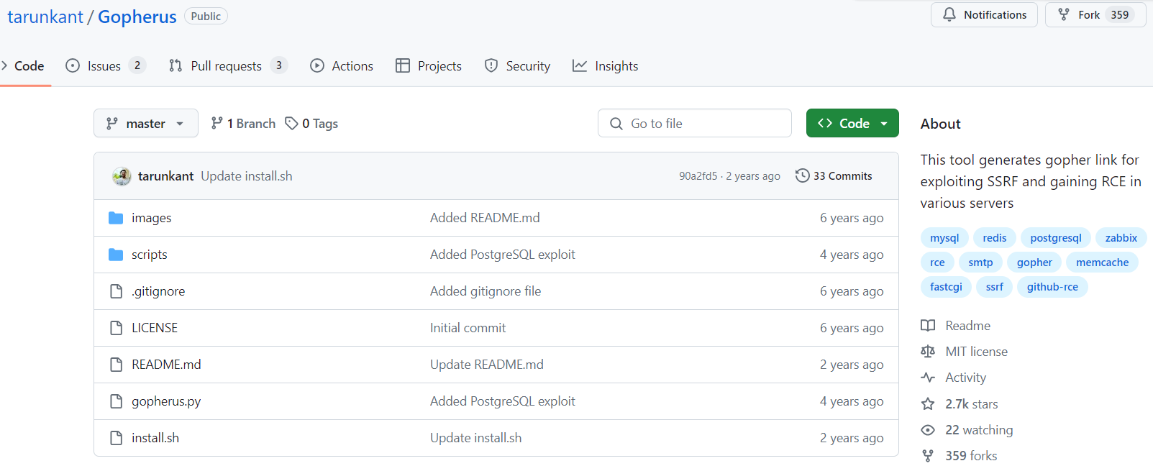
Fig. 3.55 Gopherus github

Step 3: Generating the Payload
We run the Gopherus tool to generate a payload for the SSRF exploit.
python2 gopherus.py --exploit fastcgi
This command instructs Gopherus to generate a payload that can exploit the FastCGI protocol via SSRF. Figure 3.46 shows Gopherus payload generation. When prompted, we enter the name of a file we know exists on the server, such as convert.php. Gopherus generates a payload URL that can be used to perform the SSRF exploit.
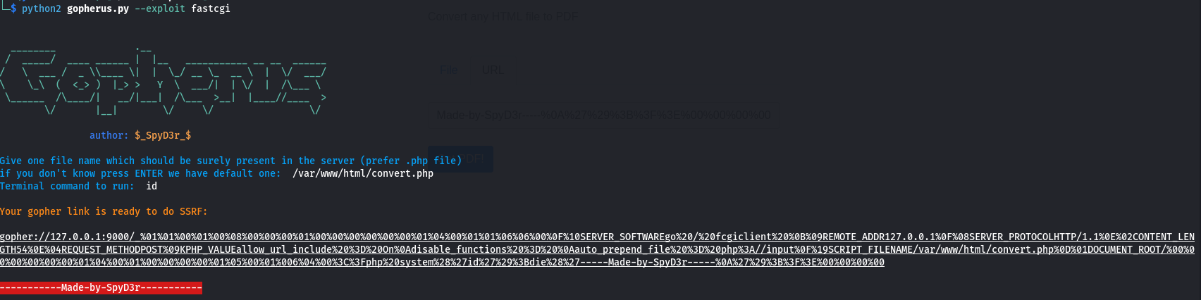
Fig. 3.56 Payload generating with Gopherus

Step 4: Executing the Payload
Using the generated payload, we proceed to access the server and execute commands. The payload URL is crafted to send a request to the server that includes our command.
Payload Example:
This payload is designed to exploit the FastCGI interface and run the id command on the server. Figure 3.57 shows SSRF Payload Execution.
- We navigate to the payload URL in a browser or use a tool like Burp Suite to send the request.
- The payload is executed on the server, and the result is returned to us.

Step 5: Viewing the Result
The result of the command execution is displayed in our browser or terminal. Figure 3.57 shows the Command Execution Result.
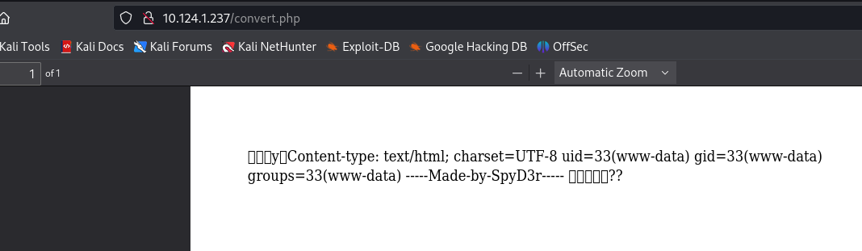
Fig. 3.57 RCE result

The output of the id command is shown, displaying user information such as uid=33(www-data) gid=33(www-data) groups=33(www-data). This confirms that we have successfully executed code on the server.

Step 6: Retrieving the Flag
Finally, to retrieve the flag, we execute the specified script using a similar payload. The payload is modified to run the /home/rceflag script instead of the id command. Figure 3.58 shows Flag Retrieval. We navigate to the new payload URL or send it via Burp Suite. The script executes, and the flag is returned in the response, indicating successful exploitation.
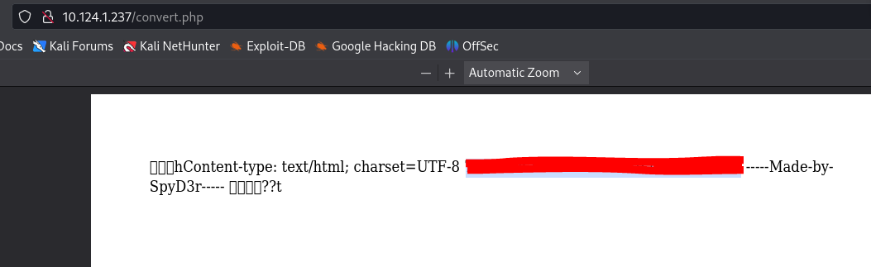
Fig. 3.58 Gaining RCE flag
Explanation:
By following these detailed steps, we exploited an SSRF vulnerability on the target server using a payload generated by Gopherus. This allowed us to achieve remote code execution, verify our access with the id command, and ultimately execute a script to retrieve the flag. This process demonstrates the power of SSRF exploits combined with tools like Gopherus to achieve significant penetration testing objectives.

Step-by-Step Guide to Remote Code Execution (RCE) Exploit on shop.edu.stf

Step 1: Task Description
The objective is to achieve Remote Code Execution (RCE) on the server shop.edu.stf (10.124.1.238) by exploiting an Arbitrary File Upload vulnerability. The goal is to execute a script located at /home/rceflag to retrieve a flag. Figure 3.59 shows Risk on shop.edu.stf. The task requires achieving RCE to run the script and obtain the flag.

Fig. 3.59 Risk on shop.edu.stf

Step 2: Accessing the Target Web Application
We access the web application at http://10.124.1.238, which appears to be an online SMS service. Figure 3.60 presents Online SMS website. The website includes a login form, indicating a potential point for file upload.
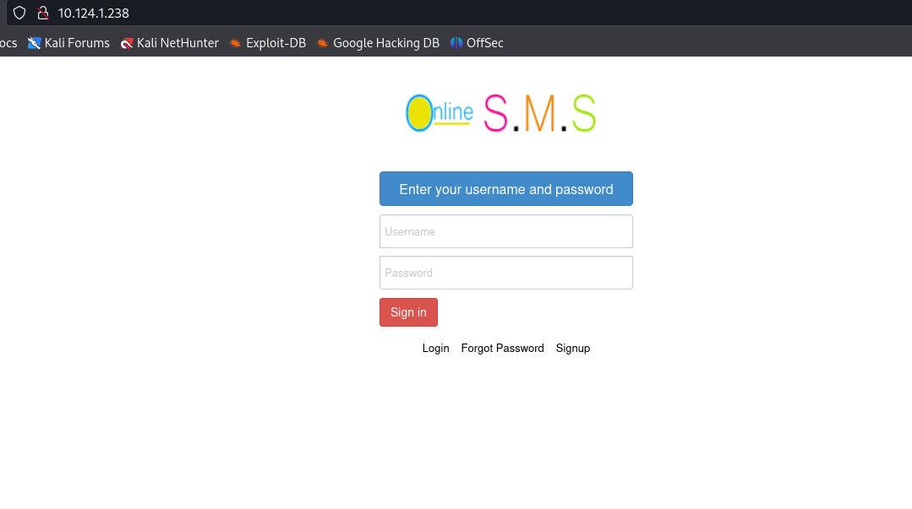
Fig. 3.60 Online SMS website

Step 3: Identifying the Vulnerability
Using a fuzzing tool, we identify various directories and files on the server. This helps locate potential endpoints for file upload. Figure 3.61 presents Directory fuzzing result. The directory /Execute/ contains multiple PHP files that could be used for the exploit.
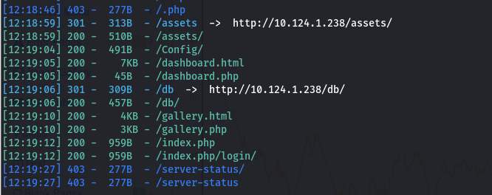
Fig. 3.61 Directory fuzzing result

Step 4: Finding the Exploit
We refer to an existing exploit in the Exploit-DB database for the Phone Shop Sales Management System, which is vulnerable to arbitrary file uploads. Figure 3.62 shows Exploit-db. The exploit outlines how to perform the file upload and achieve RCE.
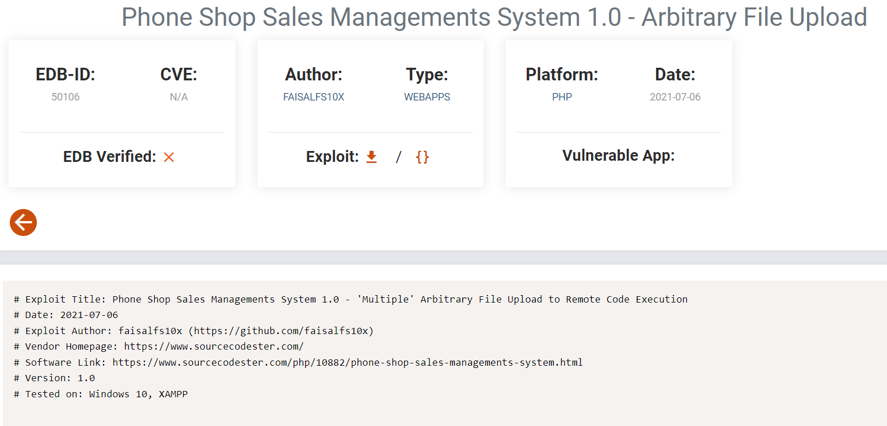
Fig. 3.62 Exploit-db

Step 5: Crafting the Payload
Using the exploit details, we craft a malicious PHP file (rev.php) that, when uploaded, will allow us to execute arbitrary commands on the server. Figure 3.63 presents Similar .php files as in exploit. The directory /Execute/ has similar PHP files, making it a suitable target for the file upload.
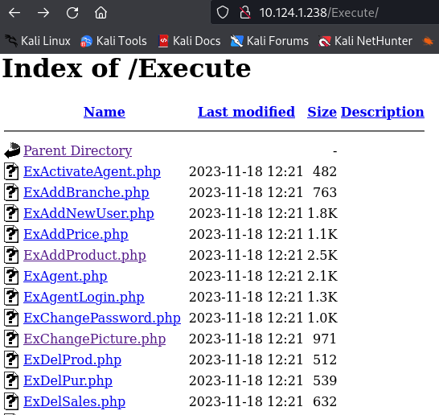
Fig. 3.63 Similar .php files as in exploit

Step 6: Uploading the Malicious File
We upload the rev.php file through one of the identified vulnerable endpoints, such as ExChangePicture.php. Figure 3.64 shows Exploiting process. The request includes our malicious PHP file disguised as an image upload.
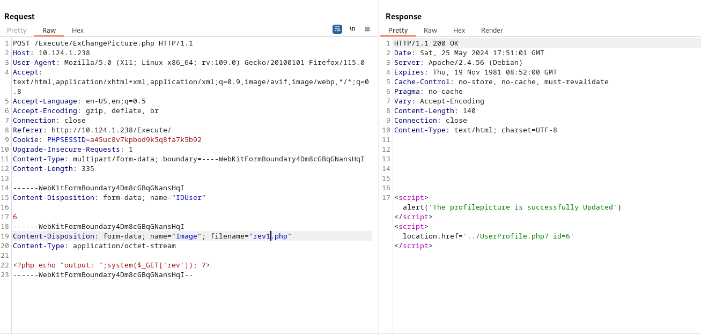
Fig. 3.64 Exploiting process

Step 7: Executing the Payload
After successfully uploading the file, we access it via the web to execute our commands. Figure 3.65 shows Gaining RCE access.We access the uploaded file at http://10.124.1.238/assets/img/Profile_Uploaded/rev.php?rev=id, which executes the id command and confirms our access.
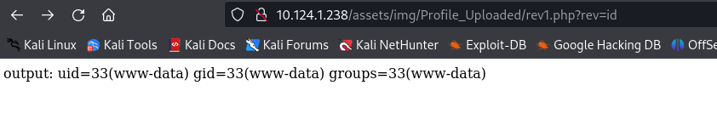
Fig. 3.65 Gaining RCE access

Step 8: Retrieving the Flag
Finally, we execute the script to retrieve the flag by modifying the command to run the /home/rceflag script. Figure 3.66 shows Gaining RCE flag. Accessing http://10.124.1.238/assets/img/Profile_Uploaded/rev.php?rev=/home/rceflag executes the script and returns the flag, indicating successful exploitation.
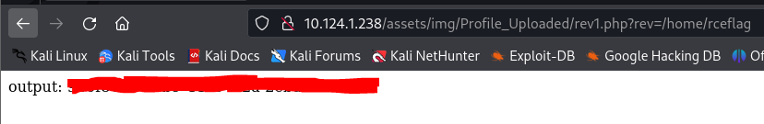
Fig. 3.66 Gaining RCE flag
Explanation:
By following these detailed steps, we exploited an Arbitrary File Upload vulnerability on the target server using a crafted PHP payload. This allowed us to achieve remote code execution, verify our access with the id command, and ultimately execute a script to retrieve the flag. This process demonstrates the effectiveness of using known vulnerabilities and existing exploits to achieve significant penetration testing objectives.

